AI ASSISTED CODING

ASSIGNMENT-6.1

2403A51273

BATCH-12

Task :1

Use AI to create an Employee class with attributes (name, id, salary) and a method to calculate yearly salary.

**code:**

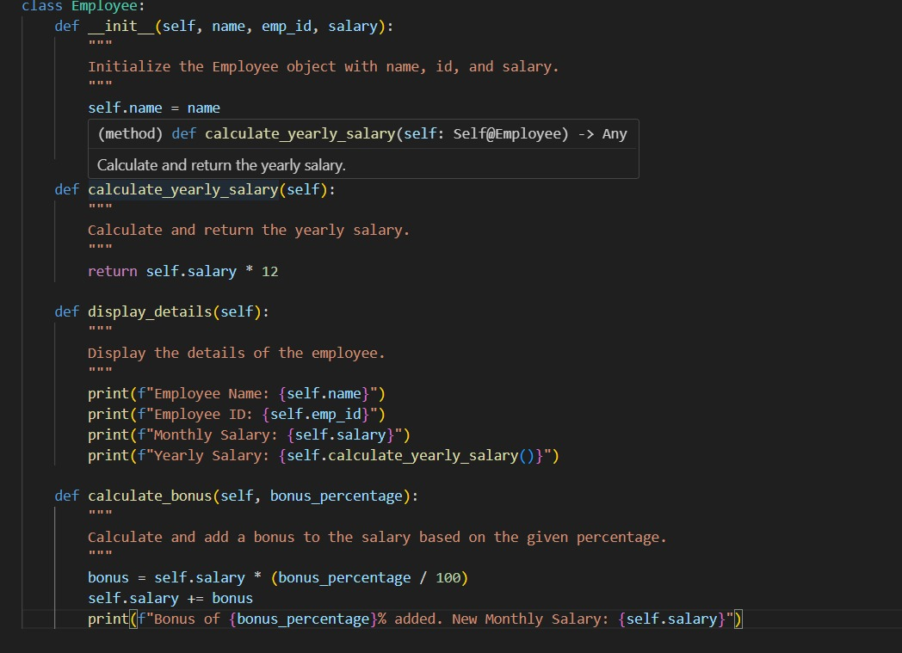

# output:

Employee Name: John Doe

Employee ID: 101

Monthly Salary: 5000

Yearly Salary: 60000

---- After Bonus ----

Bonus of 10% added. New Monthly Salary: 5500.0

Employee Name: John Doe

Employee ID: 101

Monthly Salary: 5500.0

Yearly Salary: 66000.0

# Task :2

Prompt AI to generate a function that displays all Automorphic numbers between 1 and 1000 using a for loop

Code:

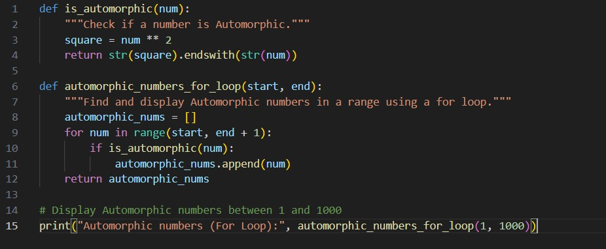

# Output:

Automorphic numbers (for loop):

1 5 6 25 76 376 625

Automorphic numbers (while loop):

1 5 6 25 76 376 625

# Task:3

Ask AI to write nested if-elif-else conditions to classify online shopping feedback as Positive, Neutral, or Negative based on a numerical rating (1–5).

# Code:

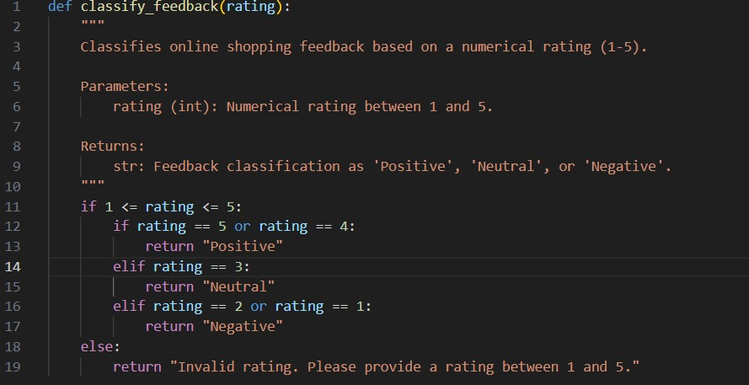

# Output:

Positive

Positive

Neutral

Negative

Negative

Invalid rating. Please provide a rating between 1 and 5.

Invalid rating. Please provide a rating between 1 and 5.

Task 4:

Generate a function using AI that displays all prime numbers within a user-specified range (e.g., 1 to 500).

# Code:

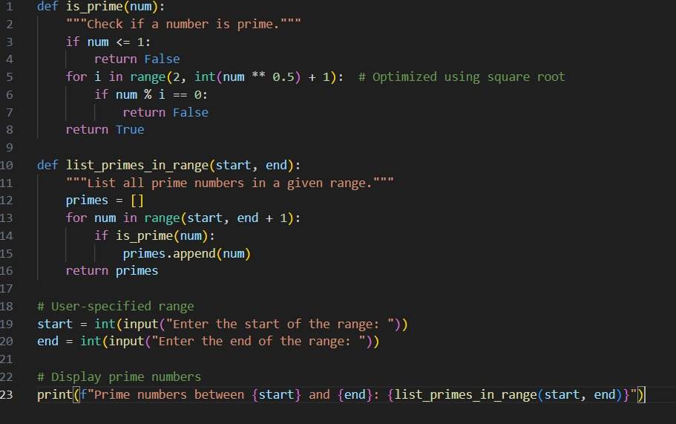

# Output:

Enter the start of the range: 1

Enter the end of the range: 20

Prime numbers between 1 and 20: [2, 3, 5, 7, 11, 13, 17, 19]

# Task :5

Use AI to build a Library class with methods to add_book(), issue_book(), and display_books().

Code:

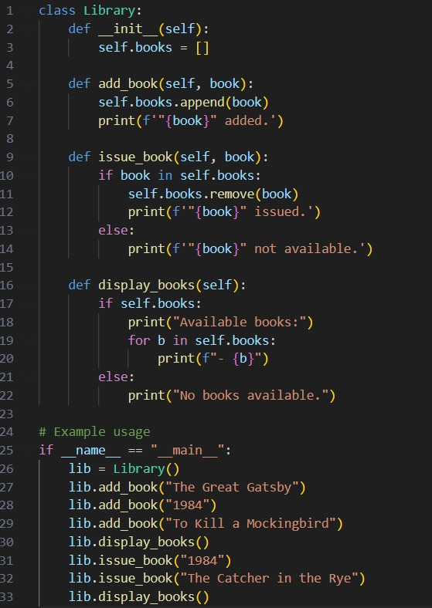

# Output:

"The Great Gatsby" added.

"1984" added.

"To Kill a Mockingbird" added.

Available books:

- The Great Gatsby

- 1984

- To Kill a Mockingbird

"1984" issued.

"The Catcher in the Rye" not available.

Available books:

- The Great Gatsby

- To Kill a Mockingbird